1. **Navigate to Home Page**

Step 1- Click on Home link on the top

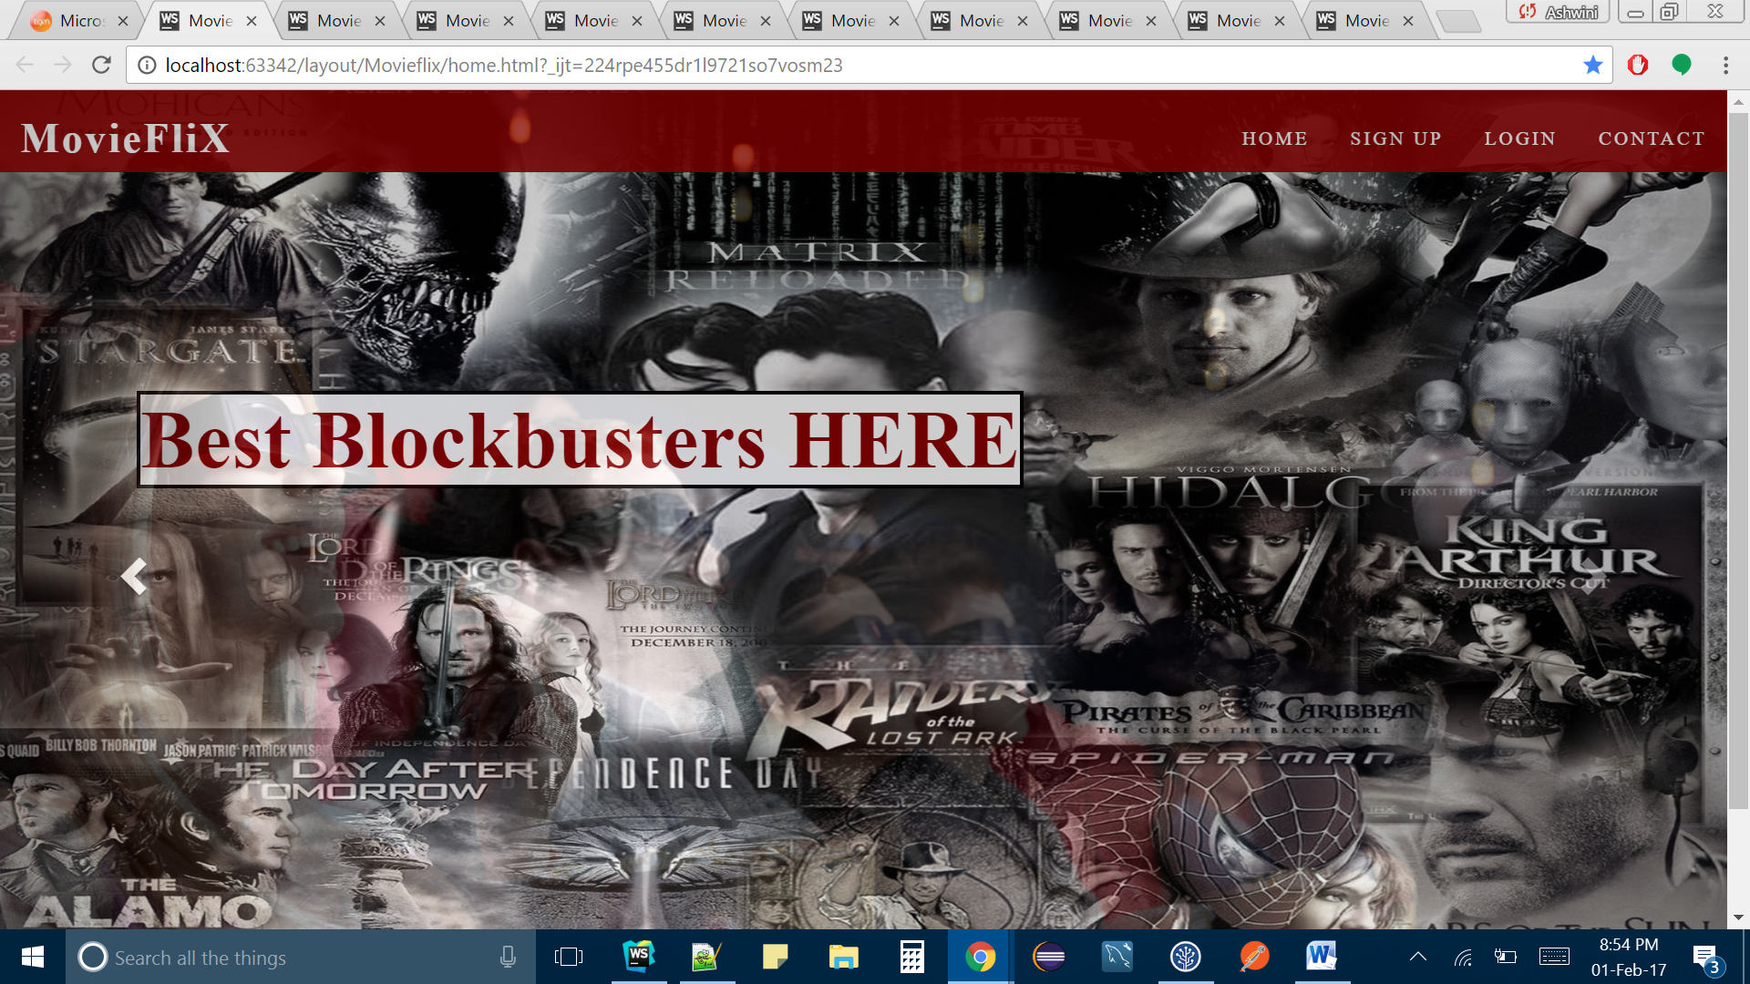

1. **Signup**

Step 1- Click on Signup link on the top of home page

Step 2- Fill in all the form fields

Step 3- Click on Signup button

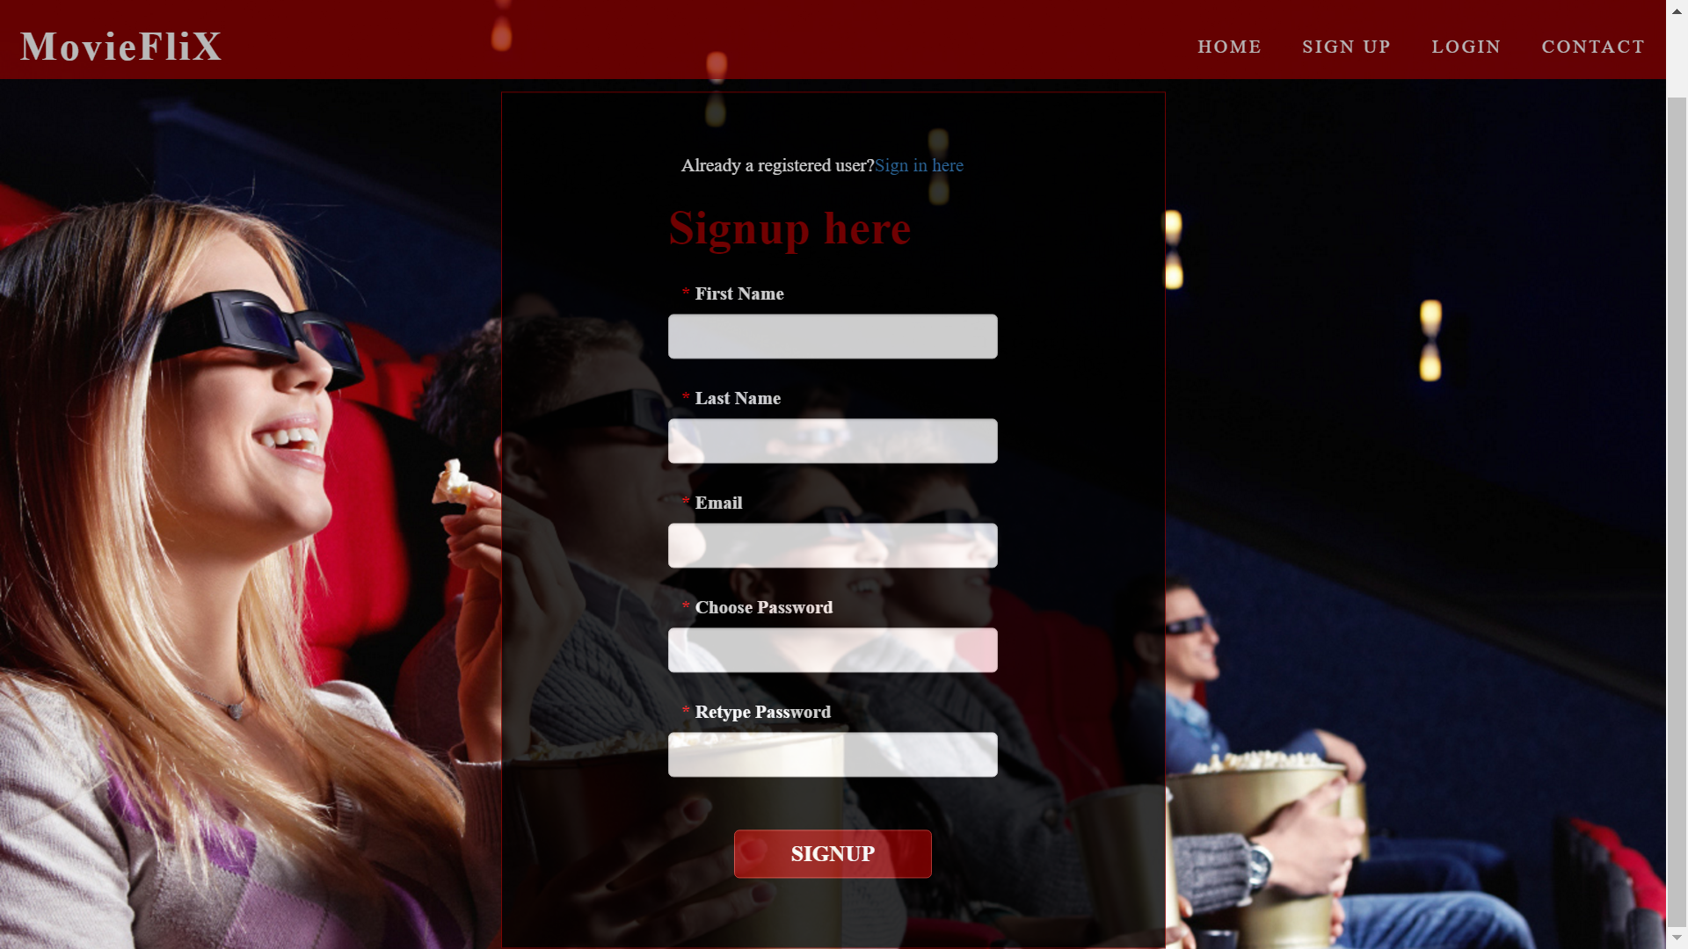

1. **Login**

Step 1- Click on Login link on the top of home page

Step 2- Fill in Email and password

Step 3- Click on Log In button



1. **Contact**

Step 1- Click on Contact link on the top of home page



1. **Logged In As Admin – Add a New Title**

Step 1- Click on ‘Add Title’ link on the top bar

Step 2- Fill in all the details

Step 3- Click on ‘Save’ button

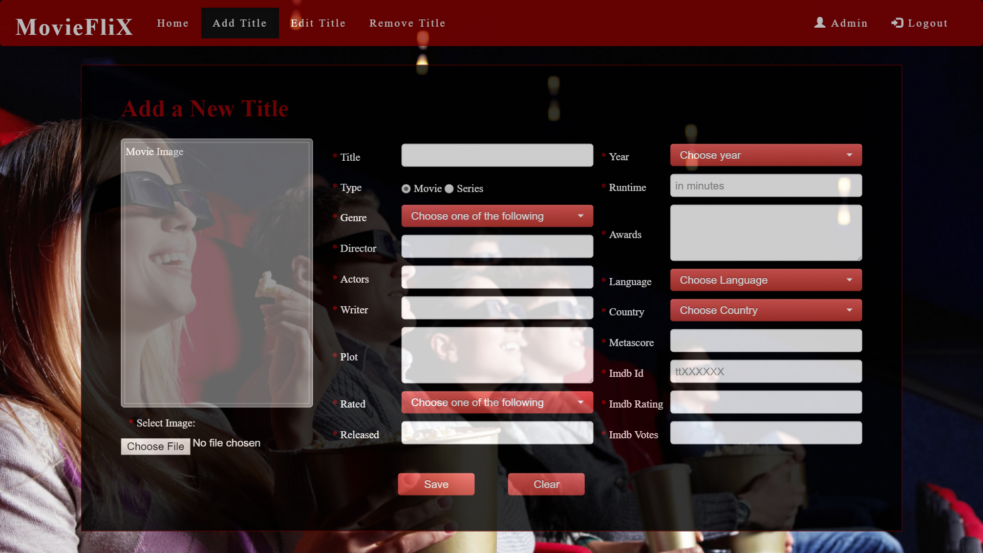

1. **Logged In As Admin – Edit Title**

Step 1- Click on ‘Edit Title’ link on the top bar

Step 2- Click on Edit icon corresponding to the title you want to edit

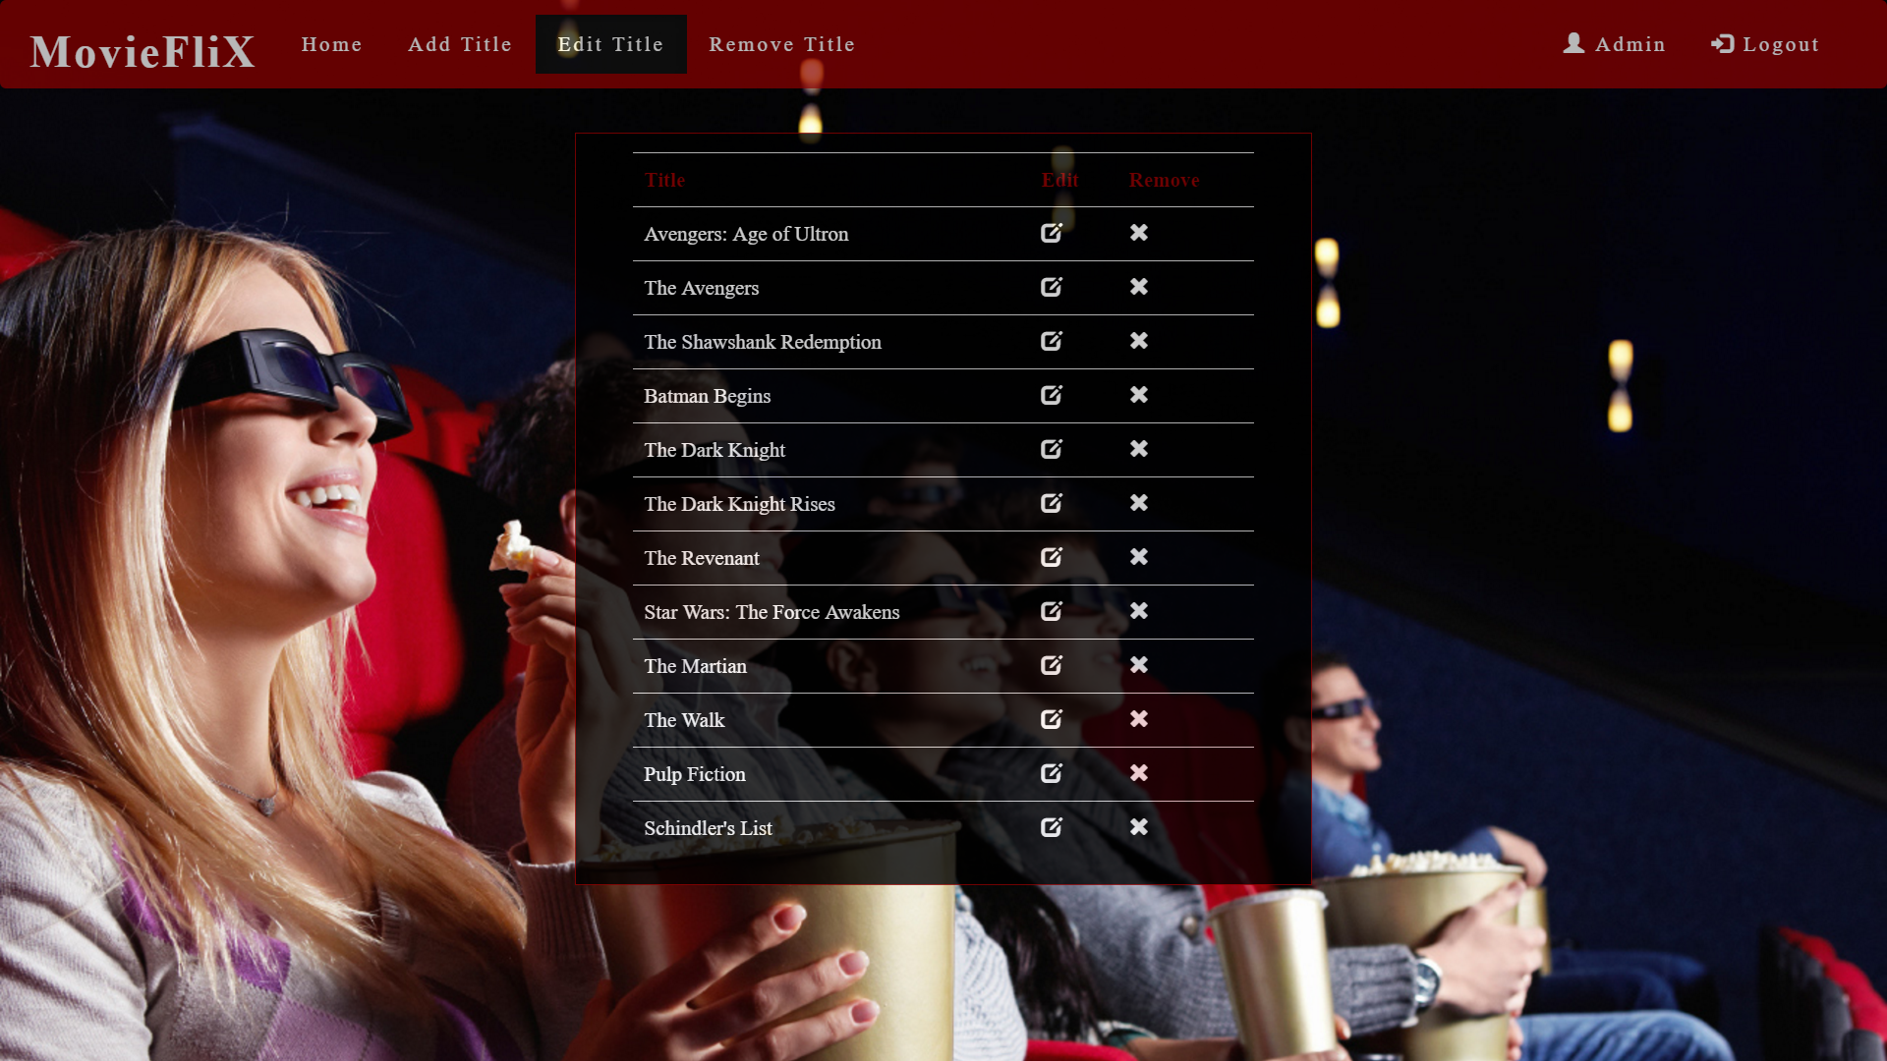

1. **Logged In As Admin – Remove Title**

Step 1- Click on ‘Remove Title’ link on the top bar

Step 2- Click on Remove icon corresponding to the title you want to remove

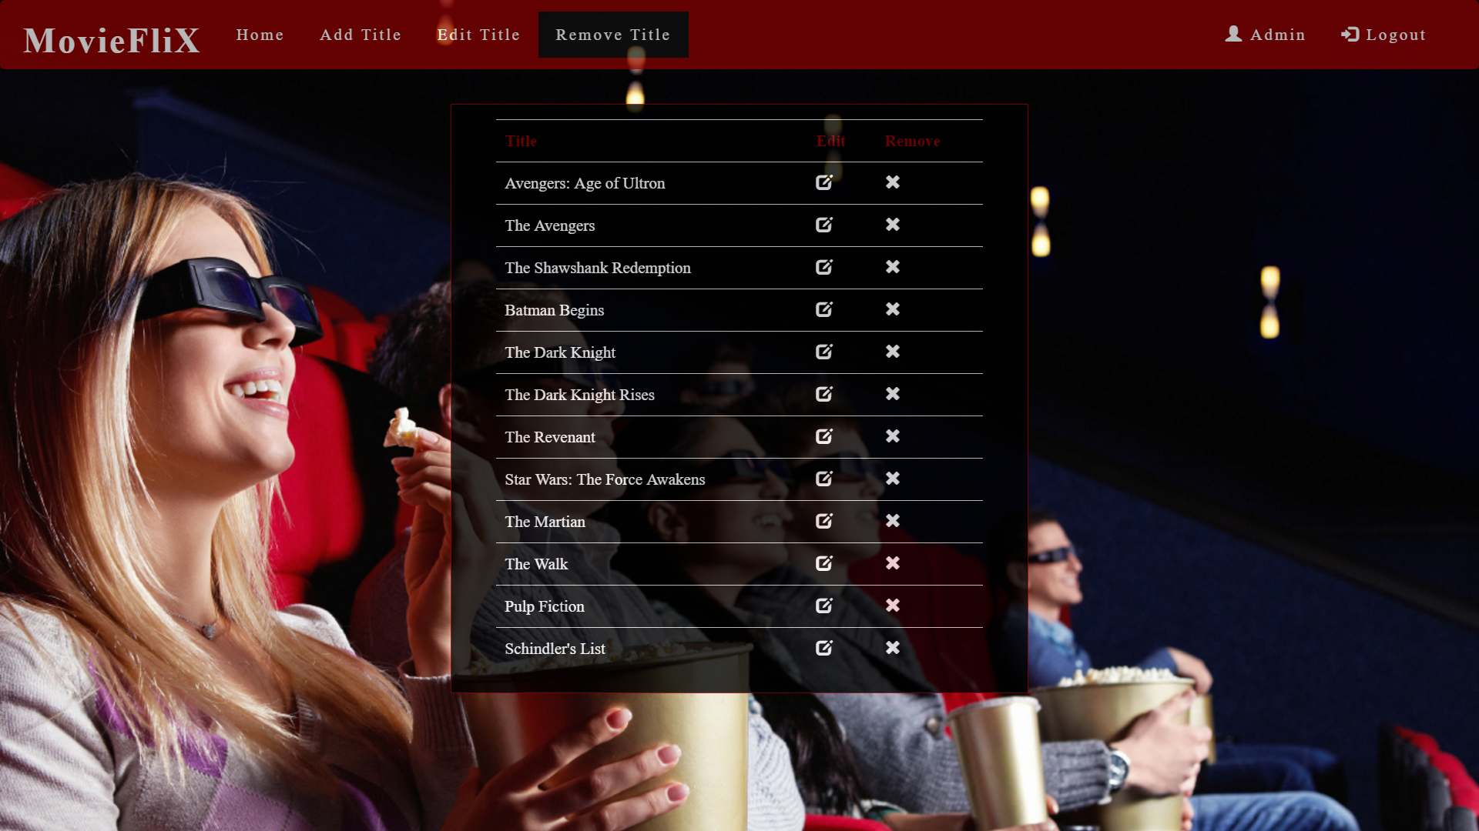

1. **Logged In as User/Admin- Browse Movies/Series**

Step 1- Click on ‘Home’ link on the top bar, after logged in as a user/admin

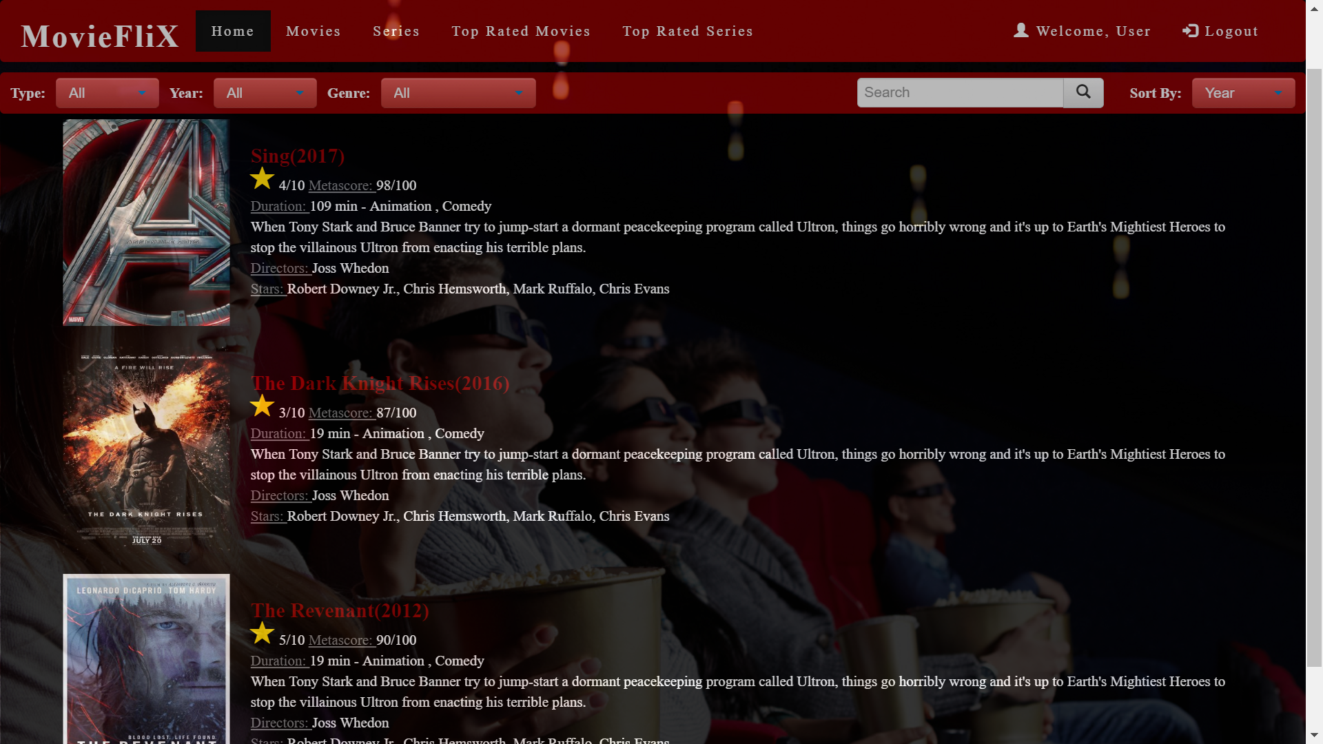

1. **Logged in as User- See Details of movie/series**

Step 1- Click on the Title of a movie from the list on home page

